Code Club Mini test

**Q1**

Write a program that will take in a number from the user via the command line (using input(…)), then using this number print out only the even digits between 0 and the number entered in by the user.

For example if I enter in 20, the program should print all even numbers between 0 and 20.

**Q2**

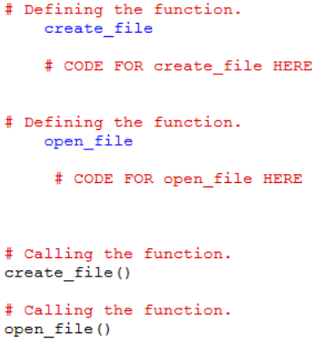Write a program that contains two functions; ‘create_file’ and ‘open_file’. ‘create_file’ should create an empty text tile and fill it with some example text. ‘open_file’ should open the file you just created and display the contents back to the screen.

The file structure should look like this:

**Q3**

Write a program that takes in a number via the command line form the user. Using a while loop, check to see if the number is between 0 & 100, if it’s not, keep asking for the user to enter in a number until it is between 0 & 100.

Once the user has entered in a valid number, using a for loop print out only the odd numbers between 0 and the users number.